**Game Design Document**

**V.1.0**

**Tajinder Nijjar**

**Game Overview:**

The game will be a 2D side-scrolling platformer in the style of a classic Super Mario Bros game. The objective of the game will be to reach the end of the level, with the player having to dodge various obstacles such as enemies.

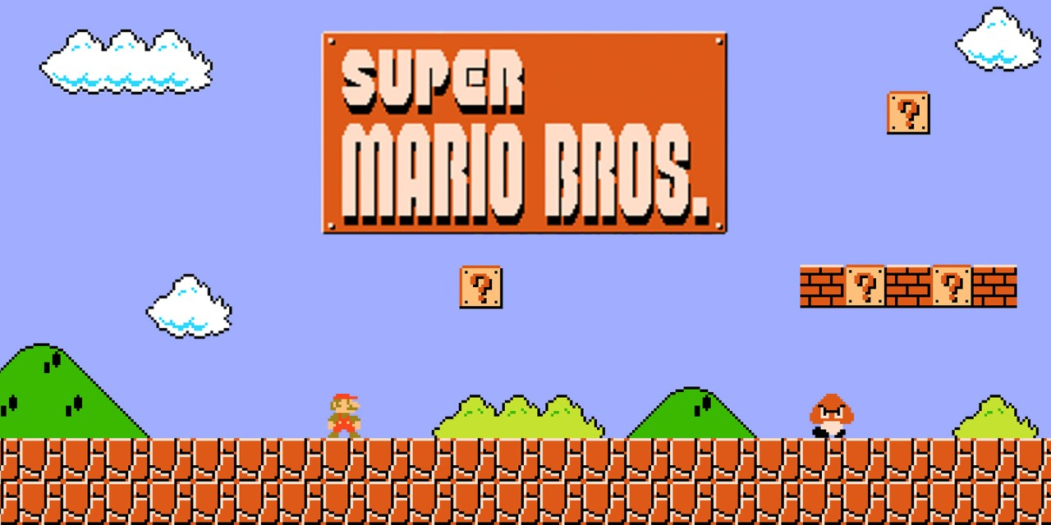

**Mechanics:**

The player character will be able to move right to left using the A and D keys. The player character can also jump using the space bar.

**Win/Lose Conditions:**

The player wins the game if they can successfully reach the end of the level(s) without depleting their health bar. The player loses the game if they fall off the map (failing to jump over a gap in the floor) or get hit by an enemy and deplete their health bar.

**Characters:**

There will be one main playable character that the player controls.

**Enemies:**

There will be a few different enemy characters with some being slow and easy for the player to avoid/defeat and some being faster and more difficult. There may even be enemies that can launch projectiles at the player.

**Obstacles:**

There will be moving platforms where the player must time their jumps/movements in order to avoid falling to the ground. There may be enemies or other items in the environment that launch projectiles at the player that the player must avoid.

**Power-ups:**

There will be power-ups that get dropped throughout the level to give the player an advantage such as a health increase, or invulnerability.